[TITLE OF FINAL YEAR PROJECT]

[NAME OF STUDENT]

UNIVERSITI TEKNIKAL MALAYSIA MELAKA

BORANG PENGESAHAN STATUS LAPORAN

JUDUL: [TITLE OF FINAL YEAR PROJECT]

SESI PENGAJIAN: [20xx / 20xx]

Saya: ____[NAME OF STUDENT IN CAPITAL LETTER]___________________

mengaku membenarkan tesis Projek Sarjana Muda ini disimpan di Perpustakaan Universiti Teknikal Malaysia Melaka dengan syarat-syarat kegunaan seperti berikut:

- Tesis dan projek adalah hakmilik Universiti Teknikal Malaysia Melaka.
- Perpustakaan Fakulti Kecerdasan Buatan dan Keselamatan Siber dibenarkan membuat salinan unituk tujuan pengajian sahaja.
- Perpustakaan Fakulti Kecerdasan Buatan dan Keselamatan Siber dibenarkan membuat salinan tesis ini sebagai bahan pertukaran antara institusi pengajian tinggi.
- * Sila tandakan ()

__________ | SULIT | (Mengandungi maklumat yang berdarjah keselamatan atau kepentingan Malaysia seperti yang termaktub di dalam AKTA RAHSIA RASMI 1972)
__________ | TERHAD | (Mengandungi maklumat TERHAD yang telah ditentukan oleh organisasi / badan di mana penyelidikan dijalankan)
__________ | TIDAK TERHAD

(TANDATANGAN PELAJAR) |  | (TANDATANGAN PENYELIA)
Alamat tetap: _____________________ |  | ________________________________
_________________________________ |  | Nama Penyelia
Tarikh: __________________________ |  | Tarikh: __________________________

CATATAN: * Jika tesis ini SULIT atau TERHAD, sila lampirkan surat daripada pihak berkuasa.

[TITLE OF FINAL YEAR PROJECT]

[NAME OF STUDENT]

This report is submitted in partial fulfillment of the requirements for the
Bachelor of [Computer Science (Artificial Intelligence)] with Honours.

FACULTY OF ARTIFICIAL INTELLIGENCE AND CYBER SECURITY UNIVERSITI TEKNIKAL MALAYSIA MELAKA
[YEAR OF SUBMISSION]

DECLARATION

I hereby declare that this project report entitled
[TITLE OF FINAL YEAR PROJECT]
is written by me and is my own effort and that no part has been plagiarized
without citations.

STUDENT : ______________________________________ Date : ________
([NAME OF STUDENT])

I hereby declare that I have read this project report and found
this project report is sufficient in term of the scope and quality for the award of
Bachelor of [Computer Science (Artificial Intelligence)] with Honours.

SUPERVISOR : ______________________________________ Date : ________
([NAME OF THE SUPERVISOR])

DEDICATION

[To my beloved parents...]

ACKNOWLEDGEMENTS

[I would like to thank En. Muhammad bin Ahmad for giving assistant to complete this project successfully…...

I would also like to thank my beloved parents who have been giving me support and motivation throughout my project…]

ABSTRACT

[Abstract must start from here. Abstracts should be concise, WRITTEN IN ONE SPACING and justification and NOT MORE THAN 300 WORDS IN A SINGLE PAGE. Abstract is not the same as synopsis or report summary. Abstracts are WRITTEN WITH ONE PARAGRAPH. It should briefly state the field of report studies, problems to be solved, solutions, research processes; and the results obtained.]

ABSTRAK

[Abstrak mesti bermula disini. Abstrak mestilah ringkas, DITULIS DALAM SATU LANGKAU dan justifikasi TIDAK LEBIH DARIPADA 300 PERKATAAN DALAM SATU MUKASURAT sahaja. Abstrak tidak sama dengan sinopsis atau ringkasan tesis. Abstrak DITULIS DALAM SATU PERENGGAN. Ia hendaklah menyatakan dengan ringkas bidang kajian tesis, masalah yang hendak diselesaikan, cara penyelesaian, proses penyelidikan; dan keputusan yang diperolehi.]

table of contents

PAGE

DECLARATION ii
DEDICATION iii
ACKNOWLEDGEMENTS iv
ABSTRACT v
ABSTRAK vi
table of contents vii
list of tables ix
list of figures x
List of Abbreviations xi
List of ATTACHMENTS xii
Chapter 1: INTRODUCTION 1
1.1 About Chapters and First Subtitle 1
1.1.1 Second Subtitles 2
1.1.1.1 Third Subtitles 2
Chapter 2: literature review AND PROJECT METHODOLOGY 3
2.1 About Figures 3
Chapter 3: REQUIREMENT ANALYSIS 5
3.1 About Tables 5
Chapter 4: DESIGN 7
4.1 About Table of Content 7
Chapter 5: RESULTS AND DISCUSSION 9
5.1 About List of Tables 9
5.2 About List of Figures 9
5.3 About List of Figures 9
5.4 About List of Figures 9
5.5 About List of Figures 10
Chapter 6: CONCLUSION 11
6.1 Wrap-Up 11
references 12
APPENDICES 13

list of tables

PAGE

Table 3.1: Table Example 5

list of figures

PAGE

Figure 2.1: Caption Window 3
Figure 2.2: Caption Numbering Window 4
Figure 2.3: Example Figure with citation from a book (Pike, 2008. Used with permission) 4
Figure 4.1: How to update Table of Contents in this template 7
Figure 4.2: Updating the whole list 7

List of Abbreviations

FYP | - | Final Year Project

List of ATTACHMENTS

 |  |  | PAGE
Appendix A |  | Sample of data | 19
Appendix B |  | Analysis of data collection | 78
…….. |  | …………
…….. |  | …………

INTRODUCTION

This template is intended to assist students in writing their FYP reports, by referring to the report structure for BAXI program. You should change accordingly to your program as stated in the guidelines. Any changes of the structure can still be made depending on your supervisor's consent.
Students are advised not to change any of the templates formatting and style since this template was built based on the FYP writing guide.
For the body of the text, students must use “Body Text 2” style in the “Styles” window under Home tab.

About Chapters and First Subtitle
For each chapter, type in the name of the chapter (e.g. Introduction) and apply “Heading 1” style. The style will automatically add numbering starting with ‘Chapter’ in front of the numbering.
Create three empty lines before each chapter name. After each chapter name, leave four empty lines for the new paragraph. Use “Body Text” style for the empty lines before and after the chapter names only. For the rest of the normal paragraph, use “Body Text 2” style, as indicated earlier. For next or new chapter, student must start on a new page.
For the first subtopic in each chapter, student can use Heading 2 style for the title. Do not leave any empty line before starting a new subtitle.

Second Subtitles
For the second subtopic of each chapter, students can choose “Heading 3” style accordingly. Do not leave any empty line before starting a new subtitle.

Third Subtitles
For the second subtopic of each chapter, students can choose “Heading 4” style accordingly. Do not leave any empty line before starting a new subtitle.

Other Subtitles
For other subtopics in each chapter use “Heading 5” style for title, with numbering (a), (b), and so on.

literature review AND PROJECT METHODOLOGY

About Figures
Figures are printed within the body of the text at the center of the page and labelled according to the chapter in which they appear. Thus, for example, figures in Chapter 2 are numbered sequentially: Figure 2.1, Figure 2.2.
Figures contain graphs, illustrations or photographs and their labels are placed at the bottom of the figure. To insert label below a figure, click “Insert Caption” under the “References” tab and select “Figure” in the dropdown list as shown in Figure 2.1.
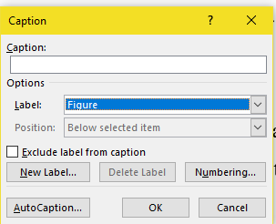
Figure 2.1: Caption Window
Click on “Numbering” and tick the “Include chapter number” and select “period (.)” as separator, as shown in Figure 2.2. Click “Update Table” to update the List of Figures.
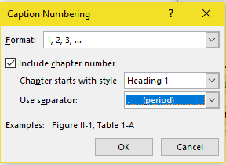
Figure 2.2: Caption Numbering Window
If the figure contains a citation, the source of the reference should be placed at the bottom, after the label.

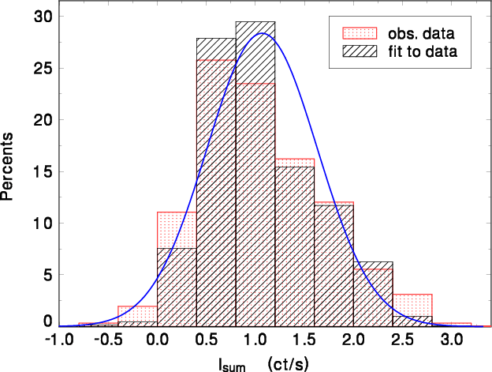
Figure 2.3: Example Figure with citation from a book
(Pike, 2008. Used with permission)

REQUIREMENT ANALYSIS

About Tables
Tables are printed within the body of the text at the center of the frame and labeled according to the chapter in which they appear. Thus, for example, tables in Chapter 3 are numbered sequentially: Table 3.1, Table 3.2. The label should be placed above the table itself and has the format shown in Table 3.1. Any text inside a table must follow “Table Text” style.
Table 3.1: Table Example
Column Name | Column Name
Text | Text

To insert label above a table, click “Insert Caption” under the “References” tab and select “Table” in the dropdown list, as shown in Figure 2.1. Click on “Numbering” and tick the “Include chapter number” and select “period (.)” as separator, as shown in Figure 2.2. When done, click “Update Table” to update the List of Tables.
If the table contains a citation, the source of the reference should be placed below the table.
To insert label above a table, click “Insert Caption” under the “References” tab and select “Table” in the dropdown list, as shown in Figure 2.1. Click on “Numbering” and tick the “Include chapter number” and select “period (.)” as separator, as shown in Figure 2.2. When done, click “Update Table” to update the List of Tables.
If the table contains a citation, the source of the reference should be placed below the table

DESIGN

About Table of Content
In this template, the table of contents rely on the use of styles to format chapter headings and subtitles and generates the table of content automatically. To generate the table of content in this template, place the cursor on the current table of content. Next, go to “References” tab and click on the “Update Table” icon, as shown in Figure 4.1.

Figure 4.1: How to update Table of Contents in this template
In the “Update Table of Contents” window, choose option “Update the entire table” and click OK. Microsoft Word will generate a new table of contents based on the student’s updates.
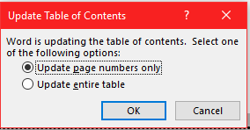
Figure 4.2: Updating the whole list
In the “Update Table of Contents” window, choose option “Update the entire table” and click OK. Microsoft Word will generate a new table of contents based on the student’s

RESULTS AND DISCUSSION

About List of Tables
To update List of Tables, place the cursor on the list that needs to be updated. Similar to the Table of Content, click on the icon “Update Table” under References tab to list down the updates, as shown in Figure 4.1

About List of Figures
To update List of Figures, place the cursor on the list that needs to be updated. Next, click on the icon “Update Table” under References tab to list down the updates, as shown in Figure 4.1.

About List of Figures
To update List of Figures, place the cursor on the list that needs to be updated. Next, click on the icon “Update Table” under References tab to list down the updates, as shown in Figure 4.1.

About List of Figures
To update List of Figures, place the cursor on the list that needs to be updated. Next, click on the icon “Update Table” under References tab to list down the updates, as shown in Figure 4.1.

About List of Figures
To update List of Figures, place the cursor on the list that needs to be updated. Next, click on the icon “Update Table” under References tab to list down the updates, as shown in Figure 4.1.

CONCLUSION

Wrap-Up
Please enjoy writing your FYP

references

Buchwalow, I. B., and Böcker, W. (2010). Immunohistochemistry: basics and methods. Berlin: Springer Verlag.

Caamaño-Tubío, R. I., Pérez, J., Ferreiro, S., and Aldegunde, M. (2007). Peripheral serotonin dynamics in the rainbow trout (Oncorhynchus mykiss) Comparative Biochemistry and Physiology Part C: Toxicology & Pharmacology. 145(2): 245-255.

Cameron, A. A., Plenderleith, M. B. and Snow, P. J. (1990). Organization of the spinal cord in four species of elasmobranch fishes: cytoarchitecture and distribution of serotonin and selected neuropeptides. The Journal of Comparative Neurology. 297: 201-218.

Desa, M.I (1995). Bus fleet maintenance modeling in a developing country. Ph.D Thesis, University of Salford.

Improve indigenous housing now, government told, 2007. accessed 8 February 2009, <http://www.architecture.com.au/i-cms?page=10220>.

International Narcotics Control Board 1999, United Nations, accessed 1 October 1999, <http://www.incb.org>.

Theusen, G. J. and Fabrycky, W. J. (1984). Engineering Economy. 6th. Ed. Englewood Cliffs, N. J.: Prentice Hall. 150-178.

APPENDICES

For footnote, choose Footnote style

